10/22/2025 DOCKET

RECEIVER HEARING 9:00 AM
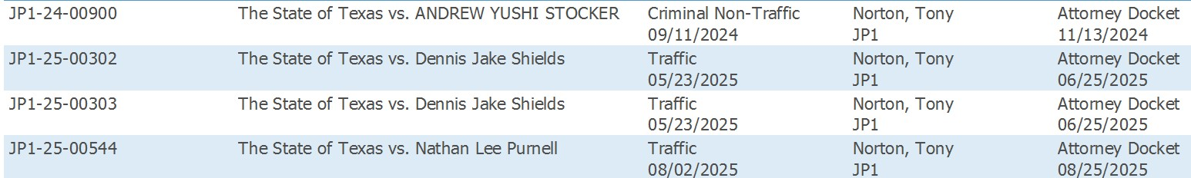

DEBT CLAIM DWOP 9:30 AM
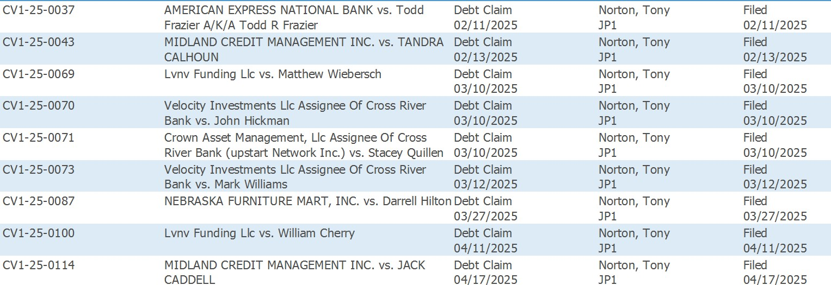

TBC SC 1:30 PM

