10/20/2025 DOCKET
SHOW CAUSE/FTSJ 9:00 AM
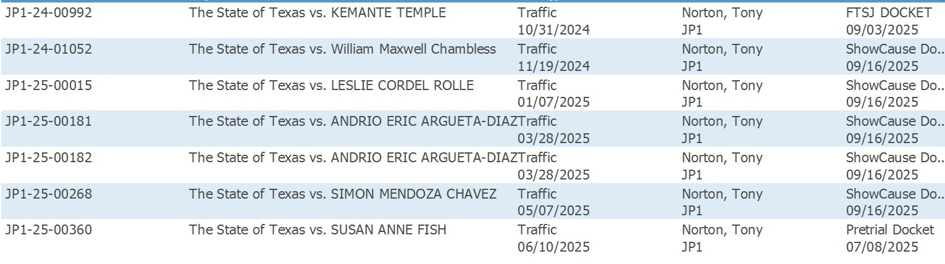
PRE-TRIAL/FTA 9:30 AM
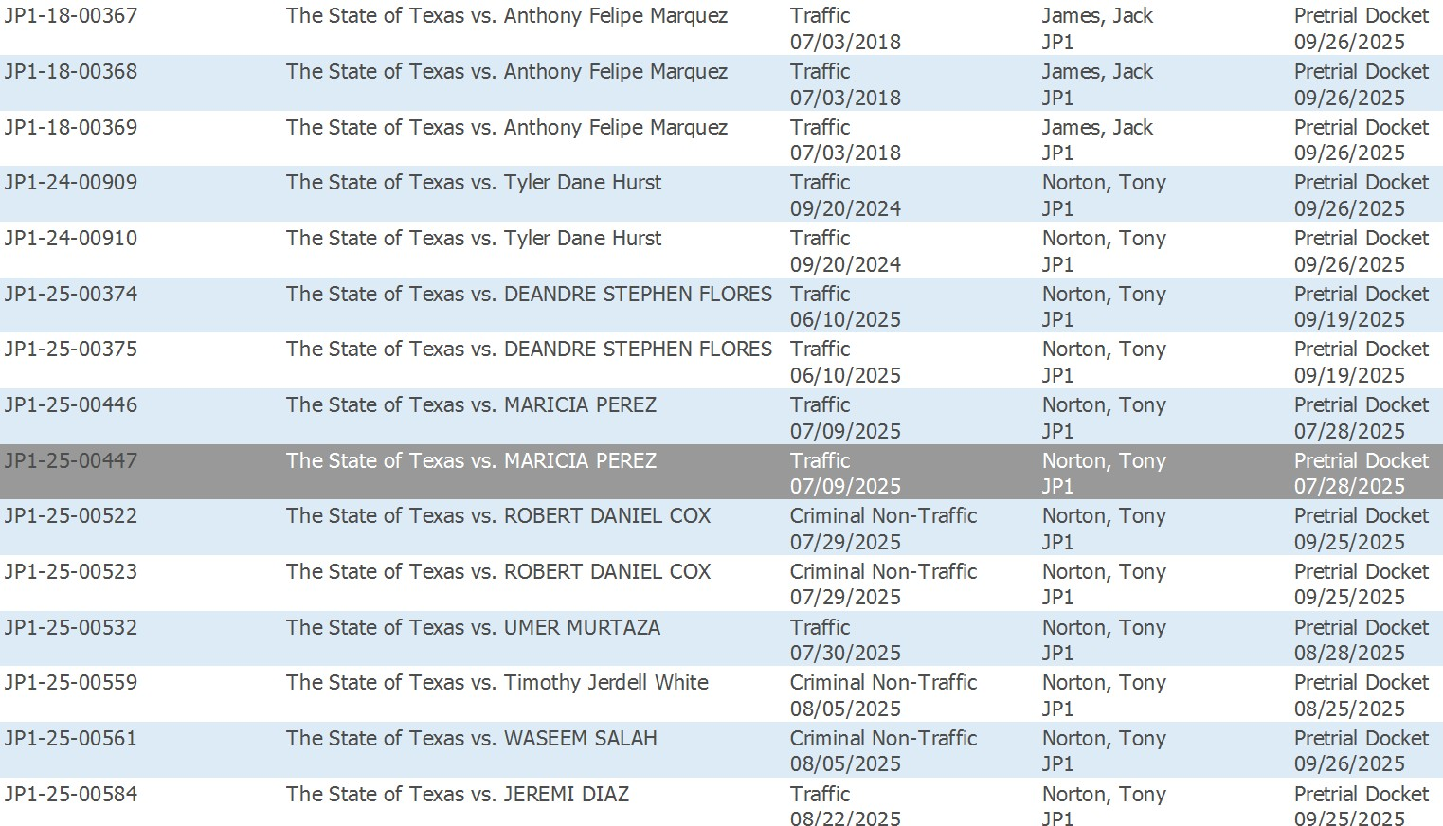
ATTORNEY DOCKET 10:30 AM
