10/08/2025 DOCKET

TRIAL BY COURT DEBT CLAIMS 9:30 AM
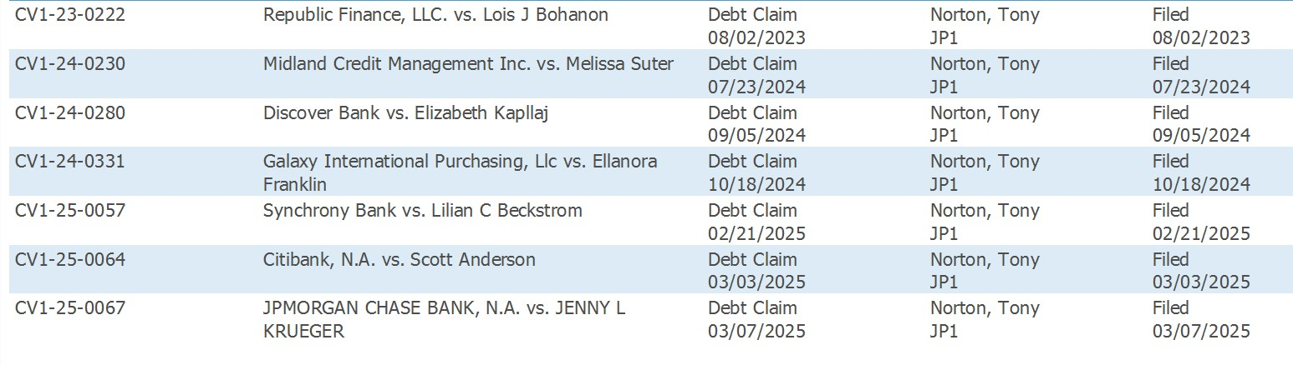

VENUE HEARING 1:30 PM

