10/15/2025 DOCKET

TBC DC 9:30 AM
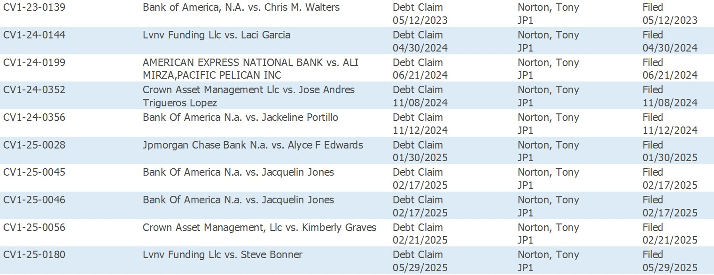

TBC SC 1:30 PM

