9/24/2025 DOCKET

DEBT CLAIM DWOP 9:30 AM
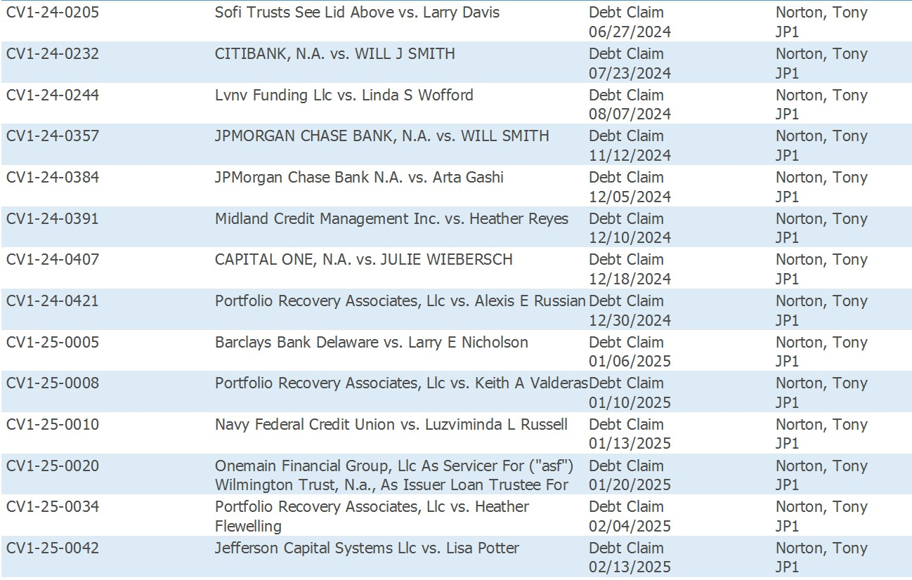

MOTION FOR DISCOVERY/SUMMARY JUDGMENT SC 1:30 PM

