9/22/2025 DOCKET
SCH/FTSJ 9:00 AM
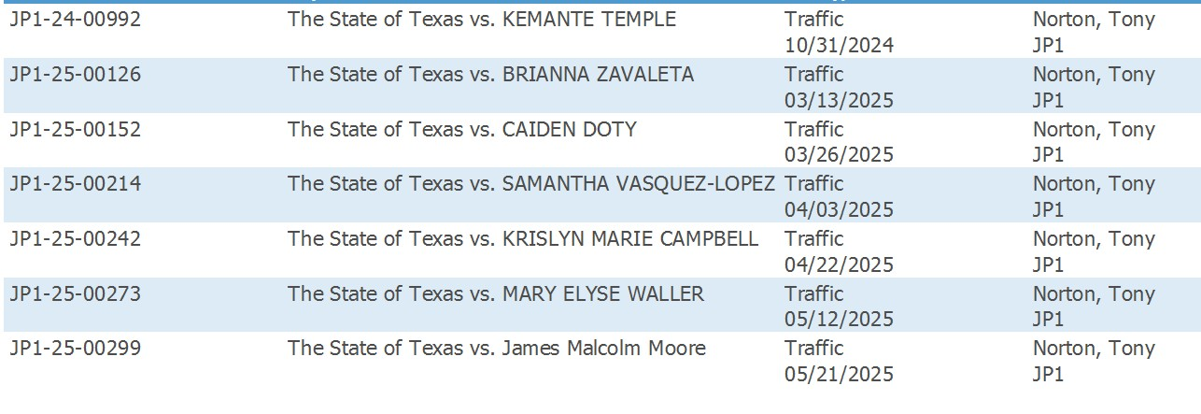
PT/FTA 9:30 AM
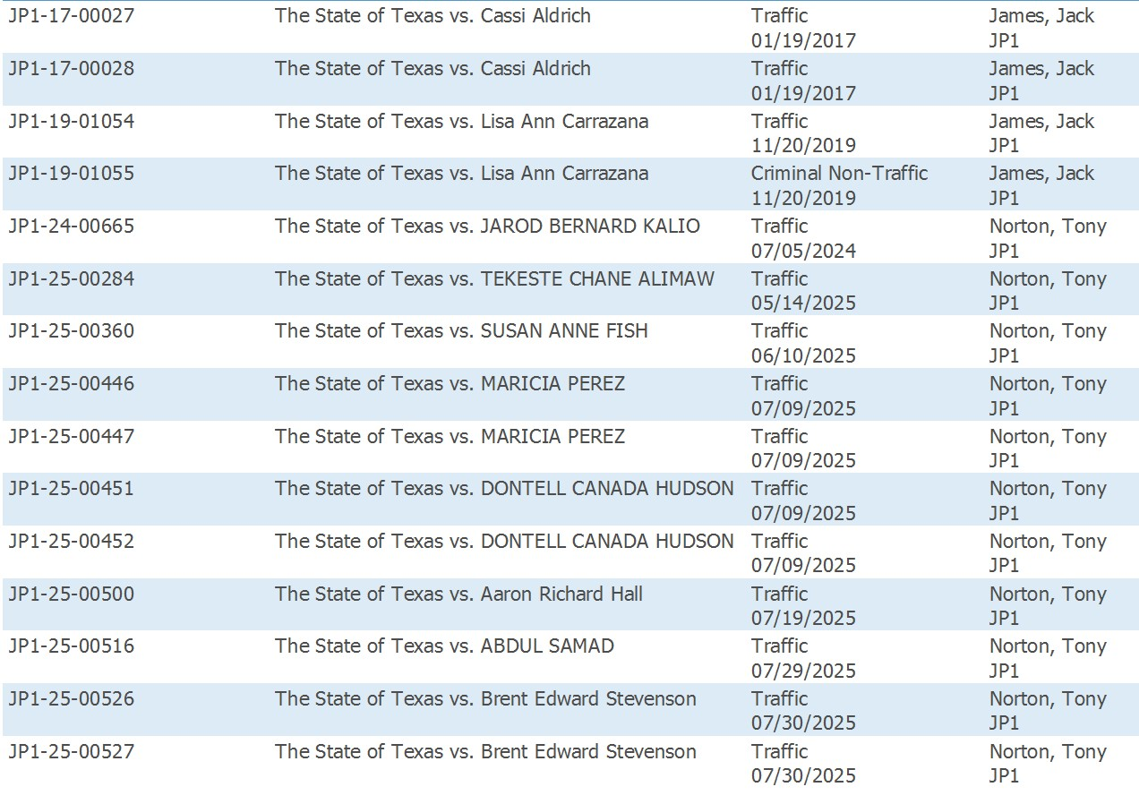
ATTORNEY DOCKET 10:30 AM
